New Patient Registration Form - Adult
Please complete all pages in full using block capitals

NORTH HARBOUR MEDICAL GROUP HARBOUR MEDI
Do you have any special communication needs? □ Yes □ No

If yes: □ Sign Language □ Large Print □ Other …………………………………………………………….
CONFIDENTIAL MEDICAL REGISTRATION FORM

Please complete all pages in FULL using BLOCK capitals
Surname
First Names (in full)
Previous Surnames
Title: □ Mr □ Mrs □ Miss □ Ms □ Male □ Female
Date of Birth (day/month/year) NHS Number □□□ □□□ □□□□
Town & country of Birth

Post Code:
Address

Telephone number: Mobile number:
Email address:

Your contact details will be used for adminstration purposes, such as sending texts/emails about appointments, routine tests, reminders. If you do not want your details to be used for these purposes, plesae speak to a member of our Reception team.
Please help us trace your previous medical records by providing the following information:

Your previous address in UK

Post Code:

Name of previous Doctor
while at that address

Post Code:
Address of previous Doctor

Where did you last receive Date:
treatment?
ie GP, Walk in Centre, MIU, Emergency Department etc
What was the outcome of
this visit? ie prescription
If you are from abroad:

Your first UK address where

Post Code:
Registered with a GP

If previously resident in UK Date you first
date of leaving came to UK

If you need your doctor to dispense medicines & appliances*:

For Dispensing Practices only:
- I live more than 1 mile in a straight line from the nearest chemist

If you are returning from the Armed Forces:

Addresss before enlisting

Post Code:

Enlistment date Service/
Personnel number
NHS Organ Donor registration:

I want to register my details on the NHS Organ Donor Register as someone whose organs/tissue may be used for transplantation after my death. Please tick the boxes that apply.

□ Any of my organs and tissue or
□ Kidneys □ Heart □ Liver □ Corneas □ Lungs □ Pancreas □ Any part of my body

Signature to confirm agreement to organ/tissue donation is at the bottom of this form.
For more information please ask at reception for an information leaflet or visit the website www.uktransplant.org.uk or call 0300 123 23 23
NHS Blood Donor registration:

I would like to join the NHS Blood Donor Register as someone who may be contacted and would be prepared to donate blood. Tick here if you have given blood in the last 3 years □

Signature to confirm consent to inclusion on the NHS Blood Donor Register at the bottom of this form.

For more information, please ask for the leaflet on joining the NHS Blood Donor Register. My preferred address for donation is (only if different from above eg your place of work)

……………………..………………………………………………………………… Post code: ………………….

Patient Declaration for all patients who are not ordinarily resident in the UK

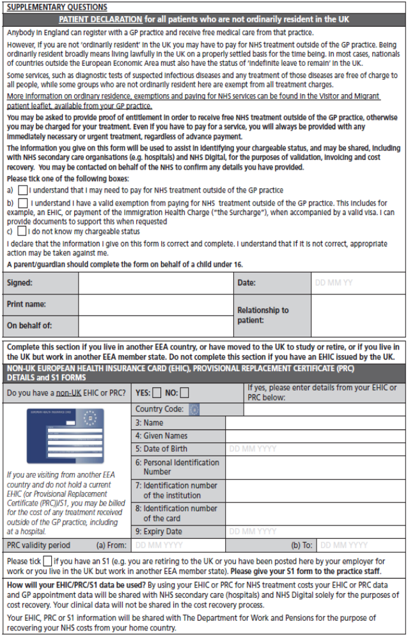

1. Background Information

Contact Details
Name |  |  |  | Gender
Address |  |  |  | Date of Birth
Address |  |  |  | Home Telephone
Address |  |  |  | Work Telephone
Mobile Telephone | I consent to be contacted* by SMS on this number:
Email | I consent to be contacted* by email at this address:
Next of Kin | Name: |  | Tel: |  | Relationship:
Family Registered With Us
* It is your responsibility to keep us updated with any changes to your telephone number, email & postal address.
We may contact you with appointment details, test results or health campaigns or Patient Participation Group details
If you do not consent to being contacted by SMS or Email, please tick here: SMS Email

Other Details
Previous GP | Name: |  | Address:
Country of Birth
Ethnicity | White (UK)  White (Irish)  White (Other) | Black Caribbean  Black African  Black Other |  | Bangladeshi  Indian  Pakistani | Arabic  Chinese  Other
Religion | C of E  Catholic  Other Christian | Buddhist  Hindu  Muslim |  | Sikh  Jewish  Jehovah’s Witness | No religion  Other:
Housing | Own House  Rented House  Shared House | Nursing Home  Residential Home  Sheltered Home |  | Homeless  Housebound | Asylum Seeker  Refugee
Employment | Employed  Student | Self-employed  Unemployed |  | House husband  House wife | Carer  Retired
Employment | International Student
Overseas Visitor | Yes | European Health Insurance Card Held (please bring details with you)
Armed Forces | Military Veteran | Family member

Communication Needs
Language | What is your main spoken language?
Communication | Do you have any communication needs? Yes No (If Yes please specify below)
Communication | Hearing aid  Lip reading | Large print  Braille | British Sign Language  Makaton Sign Language Guide dog

Carer Details
Are you a carer? | Yes – Informal / Unpaid Carer |  | Yes – Occupational / Paid Carer |  | No
Do you have a carer? | Yes | Name*: | Tel: | Relationship:
* Only add carer’s details if they give their consent to have these details stored on your medical record

2. Medical History

Medical History
Have you suffered from any of the following conditions?
Asthma  COPD  Epilepsy | Heart Disease  Heart Failure  High Blood Pressure | Diabetes  Kidney Disease  Stroke | Depression  Underactive Thyroid  Cancer- Type:
Any other conditions, operations or hospital admission details:

If you are currently under the care of a Hospital or Consultant outside our area, please tell us here:

Family History
Please record any significant family history of close relatives with medical problems and confirm which relative e.g. mother, father, brother, sister, grandparent

Asthma………………….  COPD………………...…  Epilepsy………………… | Heart Disease……….…  Stroke…………….……..  Blood Pressure………… | Diabetes………..………  Kidney Disease..………  Liver Disease..….…….. | Depression………..……  Thyroid…………..….…..  Cancer…………………..
Other:

Allergies
Please record any allergies or sensitivities below

Current Medication
Please check and include as much information about your current medication below
Please give us your previous repeat medication list if possible and a medication review appointment may be needed

3. Your Lifestyle

Alcohol
Please answer the following questions which are validated as screening tools for alcohol use:

AUDIT–C QUESTIONS | Scoring System |  |  |  |  | Your Score
AUDIT–C QUESTIONS | 0 | 1 | 2 | 3 | 4 | Your Score
How often do you have a drink containing alcohol? | Never | Monthly or Less | 2-4 times per month | 2-3 times per week | 4+ times per week
How many units of alcohol do you drink on a typical day when you are drinking? | 1-2 | 3-4 | 5-6 | 7-9 | 10+
How often have you had 6 or more units if female, or 8 or more if male, on a single occasion in the last year? | Never | Less than monthly | Monthly | Weekly | Daily or almost daily
A score of less than 5 indicates lower risk drinking |  |  |  |  | TOTAL:
Scores of 5 or more requires the following 7 questions to be completed:
AUDIT QUESTIONS  (after completing 3 AUDIT-C questions above) | Scoring System |  |  |  |  | Your Score
 | 0 | 1 | 2 | 3 | 4 | Your Score
How often during the last year have you found that you were not able to stop drinking once you had started? | Never | Less than monthly | Monthly | Weekly | Daily or almost daily
How often during the last year have you failed to do what was normally expected from you because of your drinking? | Never | Less than monthly | Monthly | Weekly | Daily or almost daily
How often during the last year have you needed an alcoholic drink in the morning to get yourself going after a heavy drinking session? | Never | Less than monthly | Monthly | Weekly | Daily or almost daily
How often during the last year have you had a feeling of guilt or remorse after drinking? | Never | Less than monthly | Monthly | Weekly | Daily or almost daily
How often during the last year have you been unable to remember what happened the night before because you had been drinking? | Never | Less than monthly | Monthly | Weekly | Daily or almost daily
Have you or somebody else been injured as a result of your drinking? | No |  | Yes, but not in last year |  | Yes, during last year
Has a relative or friend, doctor or other health worker been concerned about your drinking or suggested that you cut down? | No |  | Yes, but not in last year |  | Yes, during last year
 |  |  |  |  | TOTAL:
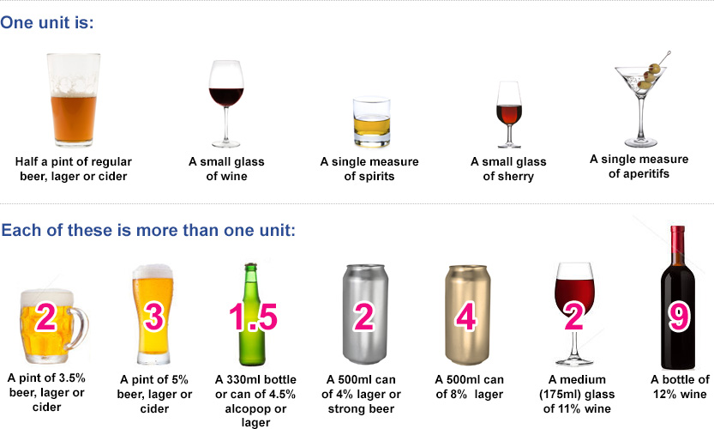

3. Your Lifestyle - Continued

Smoking
Do you smoke? | Never smoked | Ex-smoker | Yes
Do you use an e-Cigarette? | No | Ex-User | Yes
How many cigarettes did/do you smoke a day? | Less than one | 1-9 10-19 | 20-39 40+
Would you like help to quit smoking? | Yes | No
 | For further information, please see: www.nhs.uk/smokefree

Height & Weight
Height
Weight
Waist Circumference

Women Only
Do you use any contraception? | Yes No If needed, please book appointment.
Are you currently pregnant or think you may be? | Yes No Expected due date:

Students Only
Students are at risk of certain infections including mumps, meningitis and sexually transmitted infections, as well as mental health issues including stress, anxiety and depression. Please see www.nhs.uk/Livewell/Studenthealth
I am less than 24 years old and have had two doses of the MMR Vaccination | Yes | No | Unsure
I am less than 25 years old and have had a Meningitis C Vaccination | Yes | No | Unsure

Would you like a New Patient Health Check
  Yes | No

4. Further Details

Named Accountable GP
The GP who has overall responsibility for your care is?

Electronic Prescribing
If you would like your prescriptions to go electronically,  please provide details of the pharmacy you would like to use: | Pharmacy:

Patient Participation Group
Would you like to be involved in our Patient Participation Group? | Yes No
We are committed to improving the services we provide. The Patient Participation Group is a mechanism for us to gain valuable feedback from our patients about their experiences, views and ideas for improving our services.

Signatures
Signature | I confirm that the information I have provided is true to the best of my knowledge.  Signed on behalf of patient
Name
Date

Checklist
Please ensure the following are done and provided so that your registration can be completed successfully
Completed & Signed Above Form
Completed & Signed GMS1 Form
Photo Proof of ID e.g. Passport, Photo Driving License or Photo ID card
Proof of Address e.g. Bank statement, Utility Bill or Council Tax from within the last 3 months

Practice Use Only
Appointment | Required | Not Required
Photo ID | Passport | Driving licence | Identity card | Other
Proof of Address | Utility Bill | Council Tax | Bank Statement | Other

5. Sharing Your Health Record

Your Health Record
Do you consent to your GP Practice sharing your health record with other organisations who care for you?

Yes (recommended option)
No

Do you consent to your GP Practice viewing your health record from other organisations that care for you?

Yes (recommended option)
No

Your Summary Care Record (SCR)
Do you consent to having an Enhanced Summary Care Record with Additional Information?

Yes (recommended option)
No

Signature
Signature
Signed on behalf of patient
Name
Date

Sharing Your Health Record

What is your health record?
Your health record contains all the clinical information about the care you receive. When you need medical assistance it is essential that clinicians can securely access your health record. This allows them to have the necessary information about your medical background to help them identify the best way to help you. This information may include your medical history, medications and allergies.

Why is sharing important?
Health records about you can be held in various places, including your GP practice and any hospital where you have had treatment. Sharing your health record will ensure you receive the best possible care and treatment wherever you are and whenever you need it. Choosing not to share your health record could have an impact on the future care and treatment you receive. Below are some examples of how sharing your health record can benefit you:

- Sharing your contact details This will ensure you receive any medical appointments without delay
- Sharing your medical history This will ensure emergency services accurately assess you if needed
- Sharing your medication list This will ensure that you receive the most appropriate medication
- Sharing your allergies This will prevent you being given something to which you are allergic
- Sharing your test results This will prevent further unnecessary tests being required

Is my health record secure?
Yes. There are safeguards in place to make sure only organisations you have authorised to view your records can do so. You can also request information regarding who has accessed your information from both within and outside of your surgery.

Can I decide who I share my health record with?
Yes. You decide who has access to your health record. For your health record to be shared between organisations that provide care to you, your consent must be gained.

Can I change my mind?
Yes. You can change your mind at any time about sharing your health record, please just let us know.

Can someone else consent on my behalf?
If you do not have capacity to consent and have a Lasting Power of Attorney, they may consent on your behalf. If you do not have a Lasting Power of Attorney, then a decision in best interests can be made by those caring for you.

What about parental responsibility?
If you have parental responsibility and your child is not able to make an informed decision for themselves, then you can make a decision about information sharing on behalf of your child. If your child is competent then this must be their decision.

What is your Summary Care Record?
Your Summary Care Record contains basic information including your contact details, NHS number, medications and allergies. This can be viewed by GP practices, Hospitals and the Emergency Services. If you do not want a Summary Care Record, please ask your GP practice for the appropriate opt out form. With your consent, additional information can be added to create an Enhanced Summary Care Record. This could include your care plans which will help ensure that you receive the appropriate care in the future.

How is my personal information protected?
<Organisation Details> will always protect your personal information. For further information about this, please see our Privacy Notice on our website or please speak to a member of our team

For further information about your health records, please see: www.nhs.uk/NHSEngland/thenhs/records
For further information about how the NHS uses your data for research & planning and to opt-out, please see:
www.nhs.uk/your-nhs-data-matters

6. Online Access To Your Health Record
Name
NHS Number
Date of Birth
Address
Telephone
Email Address

I wish to have online access to: Please tick all that apply
View & book appointments
View & request medication
Access my coded medical record (contains any medical codes that have been recorded)
Access my full medical record (contains medical codes and any free text that has been recorded)
Access my Summary Care Record
Complete online questionnaires

I wish to access my medical record & understand & agree with each statement: Please tick all that apply
I have read and understood the ‘Important Information’ section below
I will be responsible for the security of the information that I see or download
If I choose to share my information with anyone else, this is at my own risk
I will contact the practice as soon as possible if I suspect that my account has been accessed by someone without my agreement
If I see information in my record that it not about me, or is inaccurate I will log out immediately and contact the practice as soon as possible

Please bring photographic proof of your identification in order for the process to be completed

Signature
Signature
Name
Date

For Practice Use Only:
Identity verified through  (tick all that apply) | Self Vouching  Vouching with information in record  Photo ID  Proof of residence  Professional Vouching
Name of Verifier |  | Date
Name of person who authorised and added to SystmOne |  | Date
Photocopied this page | Yes – Name:
Passed for scanning | Yes – Name:

Access to GP Online Services

Important Information – Please read before completing form below

If you wish to, you can now use the internet (via computer or mobile app) to book appointments with a GP, request repeat prescriptions for any medications you take regularly and look at your medical record online. You can also still use the telephone or call in to the surgery for any of these services as well. It’s your choice.

It will be your responsibility to keep your login details and password safe and secure. If you know or suspect that your record has been accessed by someone that you have not agreed should see it, then you should change your password immediately. If you are unable to do this for some reason, we recommend that you contact the practice so that they can remove online access until you are able to reset your password.

If you print out any information from your record, it is also your responsibility to keep this secure. If you are at all worried about keeping printed copies safe, we recommend that you do not make copies at all.

During the working day it is sometimes necessary for practice staff to input into your record, for example, to attach a document that has been received, or update your information. Therefore you will notice admin/reception staff names alongside some of your medical information – this is quite normal.

The definition of a full medical record is all the information that is held in a patient’s record; this includes letters, documents, and any free text which has been added by practice staff, usually the GP. The coded record is all the information that is in the record in coded form, such as diagnoses, signs and symptoms (such as coughing, headache etc.) but excludes letters, documents and free text.

Before you apply for online access to your record, there are some other things to consider. Although the chances of any of these things happening are very small, you will be asked that you have read and understood the following before you are given login details.

Forgotten history
There may be something you have forgotten about in your record that you might find upsetting.
Abnormal results or bad news
If your GP has given you access to test results or letters, you may see something that you find upsetting to you. This may occur before you have spoken to your doctor or while the surgery is closed and you cannot contact them.
Choosing to share your information with someone
It’s up to you whether or not you share your information with others – perhaps family members or carers. It’s your choice, but also your responsibility to keep the information safe and secure.
Coercion
If you think you may be pressured into revealing details from your patient record to someone else against your will, it is best that you do not register for access at this time.
Misunderstood information
Your medical record is designed to be used by clinical professionals to ensure that you receive the best possible care. Some of the information within your medical record may be highly technical, written by specialists and not easily understood. If you require further clarification, please contact the surgery for a clearer explanation.
Information about someone else
If you spot something in the record that is not about you or notice any other errors, please log out of the system immediately and contact the practice as soon as possible.

For further information, please see:
www.nhs.uk/NHSEngland/AboutNHSservices/doctors/Pages/gp-online-services.aspx

